CS 255 System Design Document Template

UML Diagrams

UML Use Case Diagram
This diagram summarizes the major ways customers, DriverPass employees, and the DMV interact with the proposed system. It includes customer account access, training packages, lesson scheduling, practice tests, progress tracking, driver notes, reporting, package control, user administration, and DMV updates.
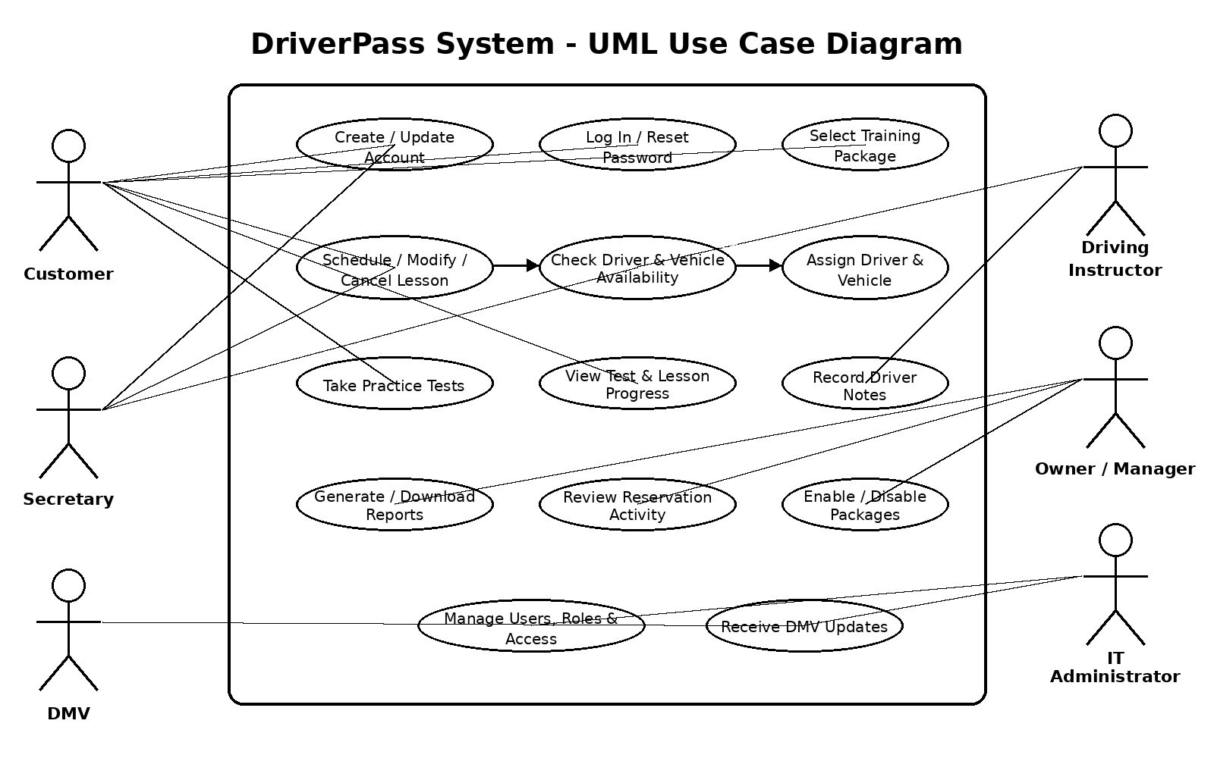

UML Activity Diagrams
Activity Diagram 1: Schedule Driving Lesson
This workflow shows how a customer schedules a two-hour driving lesson. The system verifies the customer's account and package, checks the availability of a driver and vehicle, saves the reservation, and provides confirmation. If the requested time is unavailable, the customer chooses another date or time.
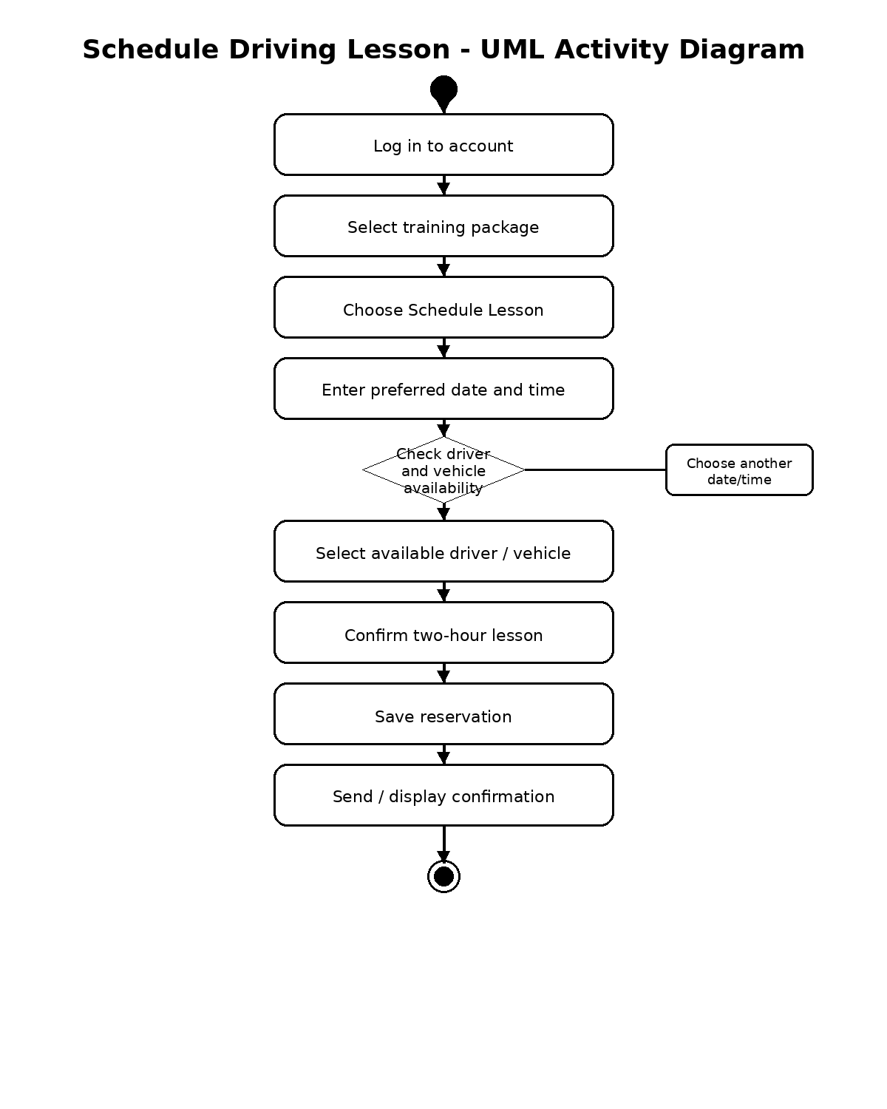
Activity Diagram 2: Take Practice Test
This workflow shows how a customer accesses a practice test, completes it, submits answers, and receives a score. The system records the time taken, score, and status so the customer's online test progress remains current.

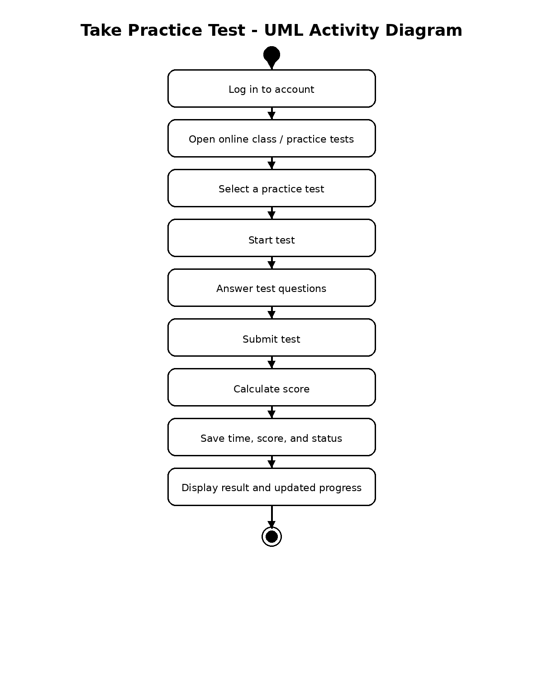

UML Sequence Diagram
The sequence diagram expands the Schedule Driving Lesson use case. It shows the order of communication among the customer, the DriverPass web system, the scheduling service, driver and vehicle records, and the database. This sequence ensures that a reservation is not confirmed until availability is checked and the reservation is stored.
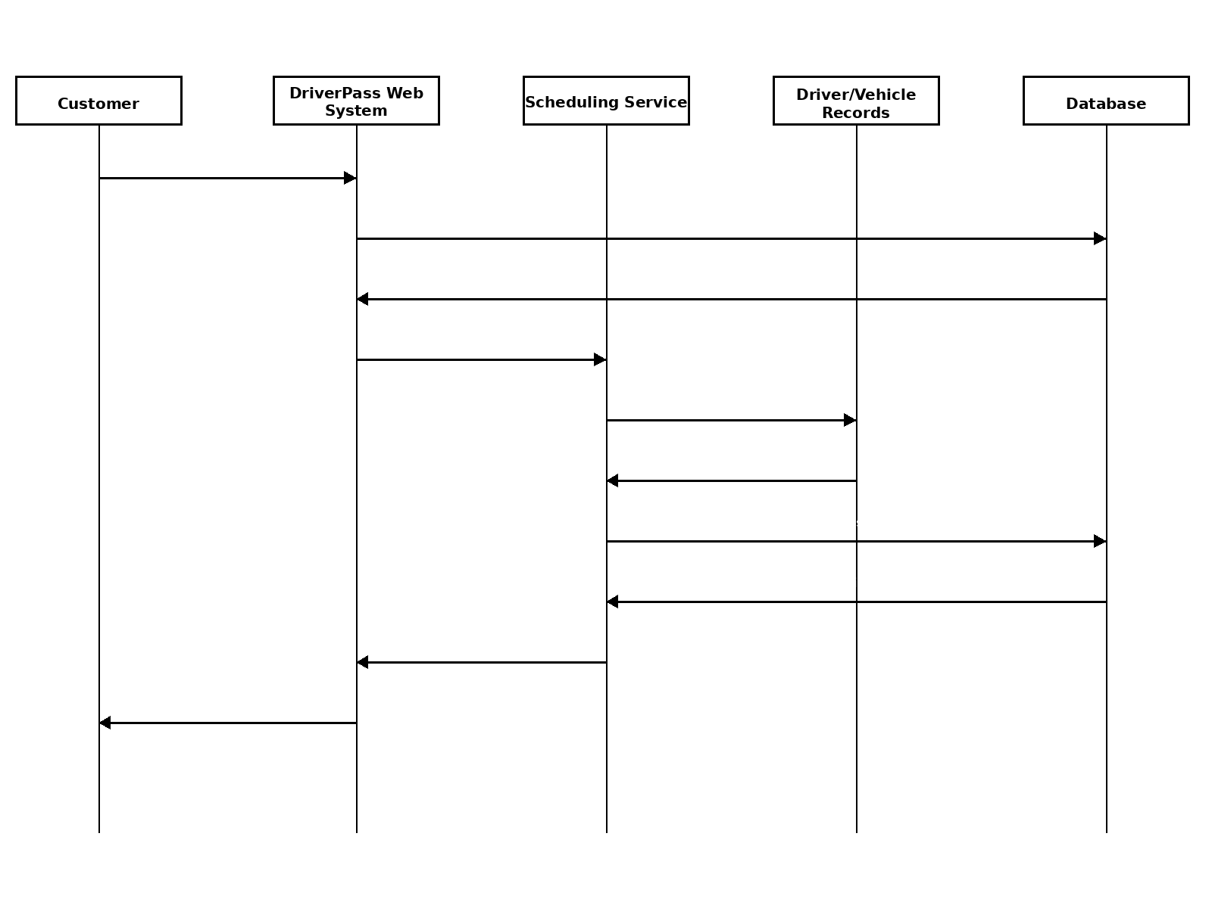

UML Class Diagram
The class diagram identifies the major information structures needed by DriverPass. User is the general account class, with Customer and Employee representing specialized users. Other classes store training packages, appointments, practice-test progress, vehicles, and driver notes. These relationships support the requirements described in the DriverPass interview.
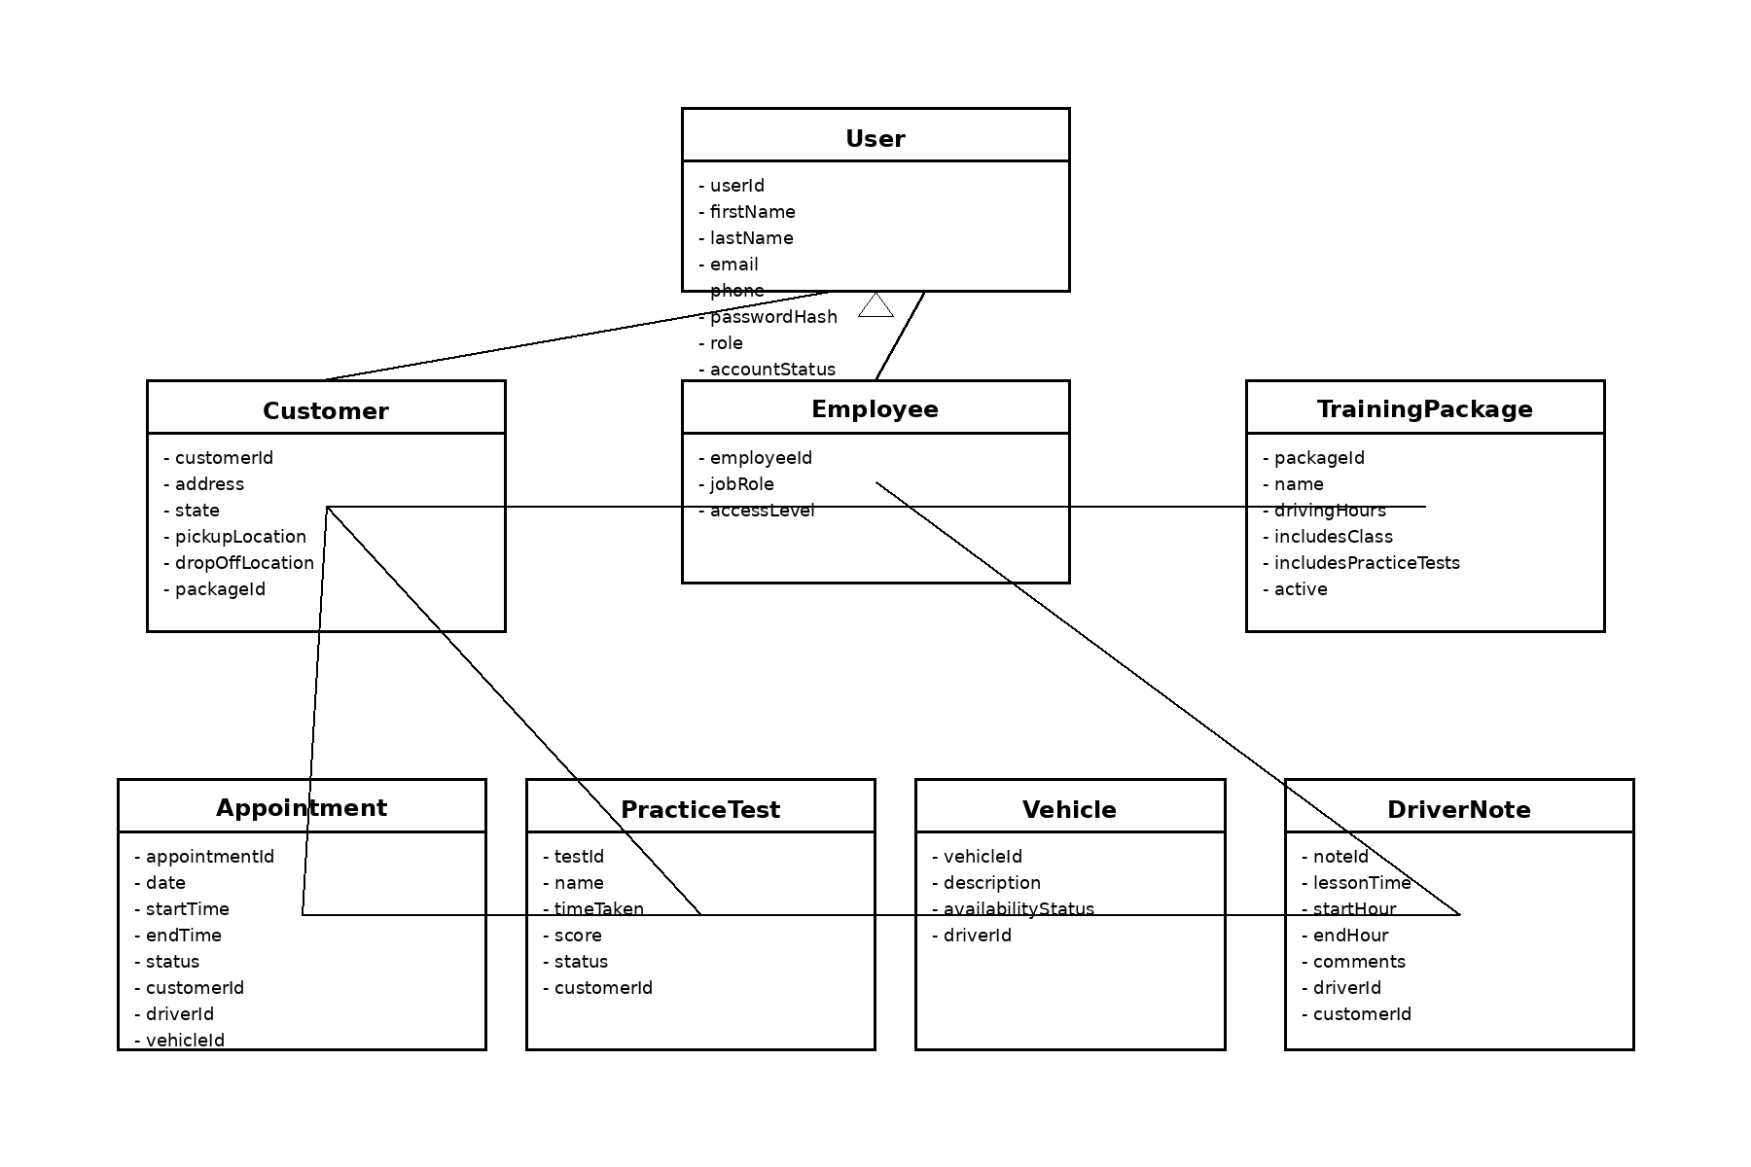

Technical Requirements

- Hardware: DriverPass users need internet-capable desktop or laptop computers and mobile devices with a modern web browser. DriverPass also needs reliable internet access. The system must support records for the company's 10 cars and their assigned drivers, but no special local server hardware is required because the client requested a web-based, preferably cloud-hosted solution.
- Software: The solution requires a responsive web application, a server-side application layer for scheduling and business rules, and a relational database for users, packages, appointments, test results, vehicles, driver notes, and activity records. The system should allow reports to be downloaded in a format that can be used in applications such as Microsoft Excel.
- Cloud and Infrastructure: The application and database should be hosted by a cloud provider, so DriverPass does not have to maintain its own backup and security infrastructure. The hosting environment should provide routine backups, recovery capabilities, secure network connections, availability monitoring, and the ability to scale as the number of customers increases.
- Security and Access: Every user must sign in through an authenticated account. Access must be based on role so customers, the secretary, driving instructors, the owner/manager, and the IT administrator only see the functions appropriate to them. The IT administrator requires full account-management access, including password resets and blocking former employees. Customer password self-reset must also be supported.
- Data Protection and Audit Trail: Data exchanged between browsers and the server must use an encrypted connection. Sensitive customer information must be protected in storage and during transmission. The system must keep an activity history showing who created, changed, or canceled reservations so DriverPass can review and print activity reports when needed.
- Scheduling and Business Rules: The scheduling component must support two-hour driving sessions and match each reservation with an available driver and vehicle. It must support the three current training packages and prevent new customers from selecting a package that DriverPass has disabled.
- DMV Integration and Content Updates: The system needs a connection or update mechanism for receiving current DMV rules, policies, and sample questions. DriverPass must receive a notification when DMV information changes so practice material can remain current.
- Compatibility and Maintainability: The system should work through common modern browsers on computers and mobile devices. Data may be viewed from different locations, but changes should be made only while online to prevent duplicating or inconsistent records. The design should be modular enough for future developer-led additions, while the current release allows DriverPass to enable or disable existing packages.

